Transition from GCSE to A level Mathematics course
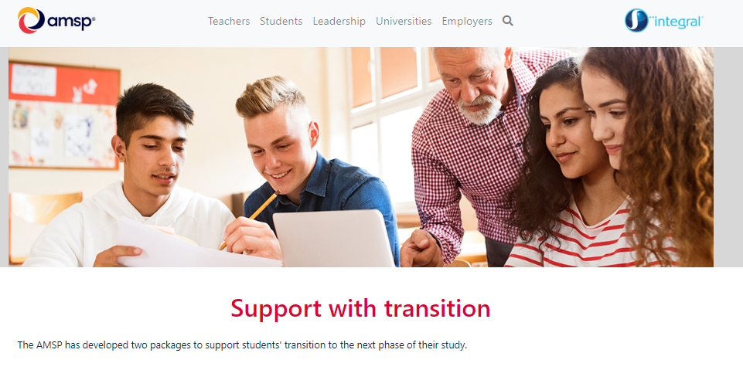
To help you consolidate the topics learnt in GCSE, Advanced Mathematics Support Programme (AMSP) runs a transition course aimed at students applying to study Mathematics at A level. This is a free online course that can be registered using your school or personal id. Your username and password will be sent to this email address so use an active Course comprises videos and interactive activities with an assessment at the end. Upon completion of the course, you will be awarded with a certificate that contains your assessment score for each module.
You must bring this certificate to your first Maths lesson at CTK in September.
Register for the course ‘Transition to A level Maths’ at https://my.integralmaths.org/integral/management/self_reg_students.php
Below QR Code will take you directly to the registration page.
